Student ID: s4664741

Student Name: Sunil Chandra Paudel

Lab Activity: 3.1

Description : Inverting an image makes it look like a photographic negative. Define and test a function named **invert**. This function expects an image as an argument and resets each RGB component to 255 minus that component. Be sure to test the function with images that have been converted to grayscale and black and white as well as color images.

Python Code (or Screen Capture)

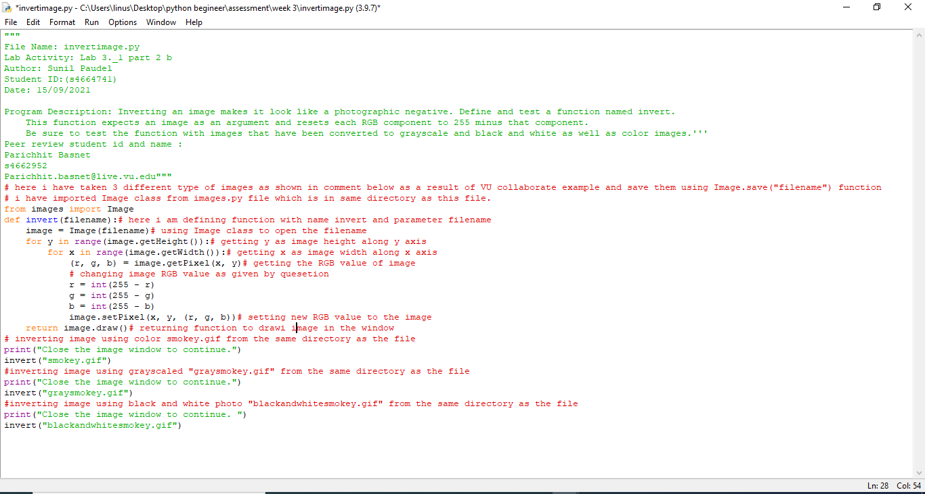

Test run (minimum 3 attempts)

My peer:

Student Name: Parichhit Basnet

Student ID: s4662952

Feed back received: Feed back received: The function are well defined, the way of coding discribes the every minute programming steps. Result is perfect as questioned has asked and programm runs smoothly

Feeback given: it is working, result is shown and comments are helping to understand.

2.c

1. Problem: Old-fashioned photographs from the nineteenth century are not quite black and white and not quite color, but seem to have shades of gray, brown, and blue. This effect is known as sepia. Write and test a function named **sepia** that converts a color image to sepia. This function should first call **grayscale** function to convert the color image to grayscale. **\*\*\***

A code segment for transforming the grayscale values to achieve a sepia effect is provided below. Note that the value for green does not change.

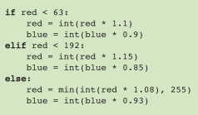

Python Code (or Screen Capture)

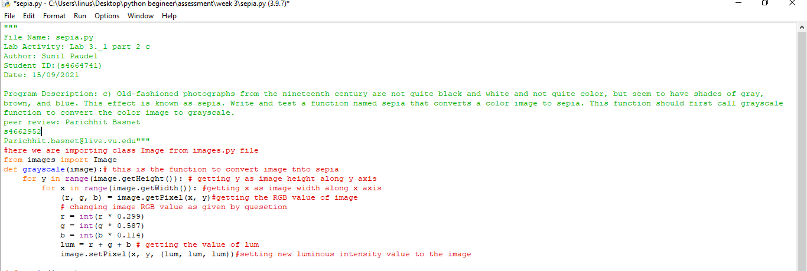

Test run (minimum 3 attempts)

My peer:

Student Name: Parichhit Basnet

Student ID: s4662952

Feed back received: : All the code are perfectly programed, the process is very smooth and easy to understand. Program runs perfectly and result is outstanding.

Feeback given:

it is working, result is shown and comments are helping to understand.